STORING XML DOCUMENTS IN RELATIONAL DATABASES
PETER GERHAT
Department of Industrial Management, National Taiwan University of Science and Technology, No.43, Sec.4, Keelung Rd., Taipei 106, Taiwan
E-MAIL: M9901802@mail.ntust.edu.tw

Abstract:
Relational database technology is currently the most widely used approach for storing large amounts of related data. In contrast, several comparable technologies exist, such as XML. There are several big differences between these two concepts, which make transferring data from one to another a significant problem. However, some similarities between them exist. Both XML documents and relational databases tend to have a well defined schema, used to describe relationships between entities. In this project results from another research were used to develop a program capable of storing XML files in a relational database. The program reads the XML schema from a DTD file, creates an optimized relational schema and generates the matching database tables. Later on, XML documents matching the schema can be inserted into the database using the program.
Keywords:
XML; relational database; DTD; schema; generating; storing

Introduction
Relational databases have become very widely accepted over the past 20 years because they are based on a formal foundation - relational algebra. Relational algebra is based on the algebra of sets and provides a formal language for their description. Also, many companies adopted them before other approaches were invented, such as objective approach. Because of their relative simplicity and great power they became a standard.

The XML language
Extensible Markup Language^{[3]} (XML) was created 10 years ago as a subset of Standard Generalized Markup Language (SGML). It is the language used for writing XML documents, which contain data stored between XML tags.
The structure of an XML document can be represented using a tree with one root node and each tag from the XML document representing one node (element) in the graph. Its advantages are that it is simple, lightweight solution and easy to use over the Internet. Data in XML are semi-structured, which means that they do not have to be fully defined by a schema.
XML is a markup language and its structure is very flexible. Without any rules elements can be combined in any way. However, it may contain only one root element and tags cannot overlap each other. For better definition of the overall schema Document Type Definition^{[2]} (DTD) may be used. DTD is also a subset of SGML. The DTD is usually kept in a separate file and referred to from an XML document.

The SQL language
Besides the relational algebra, which is a mathematical language, for describing the relational databases, the Structured Query Language (SQL) was also created. It is also standardized and used in most of today’s databases. Its main part are queries, which are expressions used for retrieving and manipulating data from the relational database.
SQL consists of several subset languages, which are used for different purposes. The format is easily recognizable by the Database Management System (DBMS) and the resulting output for each query should be the same for every implementation of DBMS. Another advantage of using SQL as a query language is that the queries can be easily generated using computer.
One of the most important subsets of SQL is Data Definition Language. The language is used for managing the table and index structure. Typical commands are CREATE, ALTER or DROP a table. It is not useful other types of queries.
Another subset is the Data Manipulation Language. The purpose of the language is to INSERT, ALTER or MODIFY rows of each table.
One of the most commonly used subsets are Queries. They also consist of a set of commands. The main purpose of queries is to retrieve data from the database. They follow a special structure. Each query starts with the declarative SELECT statement and followed by optional keywords and clauses. SELECT does not have persistent effect on the database.

Storing XML data in SQL database
The problem with storing XML data in a SQL database is that the schema which defines the data stored in XML format is different from the relational schema. XML has no relations and the data are less structured. However, in relational databases the schema is usually given before the database is created and the data inserted must be in compliance with the schema.
There is no unified way how to solve the problem, because relational database is not designed to hold semi-structured data. A possible solution is by leveraging the existing database technology.
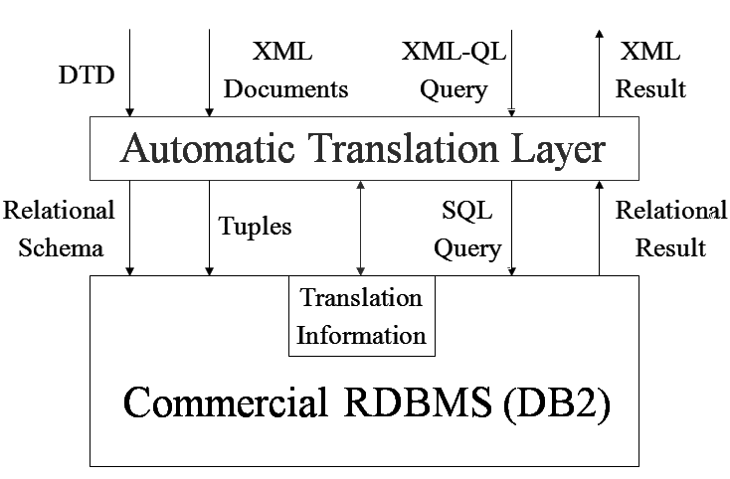
Figure 1
One of the most discussed approaches is creating an additional layer which will be responsible for handling XML data and processing XML related requests. The extra layer can be seen in Figure 1. It translates DTD to relational schema and XML documents into relational touples. It uses just few extra space of the database for storing translation information.
A viable approach was introduced in a paper about using relational databases for querying XML documents. The technique proposed will be used to make the program. The paper mentions useful techniques on how to store and query XML documents in relational databases and it’s recommended for those who are interested in this area.

Analysis
The DTD document had to be analyzed using the proposed method. The method creates only the necessary number of relations and reflects all of the information found in DTD. Therefore it is a viable approach how to create the relational schema.
When comparing the structure of a DTD and relational schema some similarities can be observed. Every line of a DTD represents a set of rules. An example of DTD is shown in Figure 2. Each line gives information about elements, which can be related with another element and the cardinalities of such relationships.
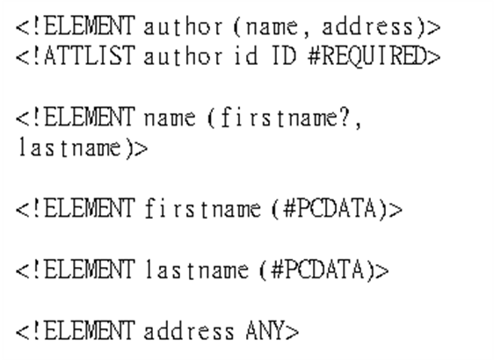
Figure 2
When rules from multiple lines are combined a graph can be modeled. The graph is called DTD graph. Each node represents one element from the DTD. The relationships between nodes represent the relationships, as defined in DTD, including their cardinality. The edges are oriented so it is easy to identify parent and child element of a relationship.
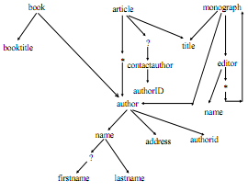
Figure 3
Next step is to split the graph into multiple relations. Here the preferred approach is to split the graph only to as many nodes as necessary to avoid extra joins. The problem arises, when a node has an in-degree greater than 2. For example this situation occurs for element Author in Figure 3. Because it can be referenced from at least 2 different nodes, the node has to be separated into a separate relationship. The same applies for nodes with an in-degree 0, which can’t be referenced from any node and therefore need to be made into a separate relation. For example element Book in the sample graph. Last condition for splitting the graph is when the node is entered by a “*” edge. In this case Monograph would have to be separated into a separate relation.
After using the technique the complete graph of the DTD was split into several smaller graphs. The nodes within the graph are all accessible with just one query. Join is necessary only when nodes from several graphs are needed.

Proposed solution
The whole process of generating relational schema and filling the created database tables with data should be automated with need only to specify the input DTD file and the XML files. For making connection to the database user will have to input information required for connection to database, such as login and password.
The program will be split into modules to reduce the overall complexity. Each module has a specific task and they work independently. First module reads the DTD file, creates and optimizes the DTD graph. Second module creates the relational schema, third module inserts the data into the database and the fourth and final module connects to the database. In the future modules may be altered for experiments with XMLSchema, other databases, optimization techniques, etc.
The main goal of the project was to develop the program, which performs the whole conversion of XML data into relational database. Following are the descriptions of each of the modules.

3.2. Relational schema module
When the DTD graph is complete it is analyzed. This is done by checking the in-degree of every node and finding every “*” relationship. The nodes are stored in an array and during the check each of the nodes is visited and its in-degree measured.
The result of this algorithm is a set of nodes, which are candidates for making them as separate relations. Some nodes may be more than once in the set and therefore it will also remove duplicate nodes.
Second task of the module is to connect to the relational database and execute queries. The module just generates the queries as strings and leaves their execution to the database connection module. The queries will create the relational tables. Elements belonging to each relations are obtained via depth traversals starting from each of the nodes on the list of selected nodes.
Finally after this module finishes executing the queries a database is ready to be filled with data, which are in form of XML files.

3.3. Data module
Data module is used each time the database has to be filled with data. While the previous two modules have to be used just once, this module needs to be used for every XML file once.
For inserting data into the database it is necessary to know the schema. Therefore, the DTD has to be loaded for this module to function. When just loading the DTD without generating a new schema the already stored data will remain intact.
The technique used for processing of the XML file was by creating a Document Object Model (DOM) of the XML file. The DOM is a tree structure representing the XML document and it has to be fitted to match the relational schema. Here the DTD graph is used for mapping the XML to the relational schema.

3.3. Database connection module
This module plays a special role, it only establishes connection to a database and executes queries. The query is passed to the module as a string and the module does the execution as a query.
For this module to function properly it is necessary to connect to a database. Therefore it needs the connection information, such as address of the database server, username and password. Also an Oracle database must be installed. Java needs JDBC API to connect to Oracle, which can be downloaded from Oracle.

Implementation
The program was implemented in Java 1.6 using Netbeans IDE 6.9.1. The version of database was Oracle 10g Express Edition running on localhost, port 1521.
There are some minor errors, which need to be removed, however, the program is functioning and performing all required tasks.
As mentioned earlier, the program stores its translation information as additional columns into every touple. These data are only for use by the program.
XML queries are currently not supported because the program should be first tested for the validity of data stored in database. Also, storing data is more important than querying and obtaining the query results because the queries can be made directly in SQL, without converting them from XQuery.
Figure 4
Create table BOOK ( bookID VarChar2(255), book VarChar2(255), book_booktitle VarChar2(255), Constraint PK_BOOK Primary Key (bookID) )
Create table AUTHOR ( authorID VarChar2(255), author VarChar2(255), author_name VarChar2(255), author_name_firstname VarChar2(255), author_name_lastname VarChar2(255), author_address VarChar2(255), Constraint PK_AUTHOR Primary Key (authorID) )
Create table TITLE ( titleID VarChar2(255), title VarChar2(255), Constraint PK_TITLE Primary Key (titleID) )
Create table MONOGRAPH ( monographID VarChar2(255), monograph VarChar2(255), monograph_editor VarChar2(255), Constraint PK_MONOGRAPH Primary Key (monographID) )
Create table ARTICLE ( articleID VarChar2(255), article VarChar2(255), article_contactauthor VarChar2(255), Constraint PK_ARTICLE Primary Key (articleID) )
Insert into AUTHOR values ('Richard','Dawkins','Timbuktu 99999')
The program features a user interface, which allows the user to input the parameters via graphical user interface. However, console output is also available for more detailed information about the run. Console output contains the program log, including the queries, which were generated.
The module for filling the database with data is not fully completed because of the time constraints on this project.

Future work
There are no plans about future work on the program, however it might be possible to finish the remaining work on storing the XML files into relational database. In the current development phase most of the work related to processing DTD was done and main focus should be on the data constraints and filling the database with data.
The accuracy could be improved by many ways. In the present stage the data type is always set to VarChar2(255). However, the constraints should match the DTD constraints. Also the IDs specified in the DTD should be respected and support for element attributes in general. Currently the program recognizes only element nodes.
Another challenging step would be to convert the queries from XQuery, which is a language for querying XML files into SQL. However, it might have many boundaries because XQuery assumes tree structure of an XML document and it might be more suitable to write queries directly in SQL. The referenced research paper also mentions issues with querying and it is recommended to see the paper for any further references.
It is also suggested to improve the user interface if the program should be used in future. The current interface provides very few information about the program activity and it doesn’t warn about the errors that may occur during processing.

Conclusion
Relational databases currently serve primarily for storing relational data. When trying to store XML data into relational database it is possible to do so almost seamlessly. Another advantage is, that the process can be fully automated. However, the data must be fully structured, which may occur seldom.
I would recommend this approach for storing data which are read mostly by machines instead of people. The reason is, that such XML documents are more structured, contain shorter values instead of long text and there is no need for the created relations to give any meaning.
The main question is, whether storing XML documents in relational databases is a good idea. Because of the big differences between these two concepts seamless integration is not possible and most likely these two concepts will remain as different as they are now. However, it was proven, that it is possible to merge multiple XML documents and store them in relational database.

References
- J. Shanmugasundaram, K. Tufte, G. He, Ch. Zhang, D. DeWitt, J. Naughton, “Relational Databases for Querying XML Documents: Limitations and Opportunities”, 25th VLDB Conference, Edinburgh, Scotland, pp. 302-314, 1999.
- J. Bosak, T. Bray, D. Connolly, E. Maler, G. Nicol, C. M. Sperberg-McQueen, L. Wood, J. Clark, “W3C XML Specification DTD”, http://www.w3.org/XML/1998/06/xmlspec-report-19980910.htm
- T. Bray, J. Paoli, C. M. Sperberg-McQueen, “Extensible Markup Language (XML) 1.0”, http://www.w3.org/TR/REC-xml

