Advanced database systems final Project report
Kai-en tsay
Department of Computer Science and Information Engineering, Nation Taiwan University of Science and Technology,
E-MAIL: M9615084@mail.ntust.edu.tw

Abstract:
With the widespread use of digital cameras and camera phones, it becomes increasingly important to devise efficient and effective methods that help users to browse, search, retrieve or annotate photos on their photo collections. In [1], they mention that given time and location information about digital photo-graphs we can automatically generate an abundance of related contextual metadata. Professor Hector and his team describe the contextual metadata that automatically assemble for a photograph, given time and location, as well as a browser interface that utilized that metadata. There is no doubt that metadata can increase the searching performance in personal photo collection, but how about the web scope? Could this method be useful in the web scope? How popularize is time and location information in the web images? This project just simply verify the idea in [1] and take a survey that how popular is time and location information available in the images on the Internet.
Keywords:
Geo-referenced digital photos; photo collection; context; exif- exchangeable file format;

Introduction
Managing personal collections of digital photos is an increasingly diﬃcult task. At the same time, the usefulness of the collected photos is in doubt, as the methods of access and retrieval are still limited.
The existing approaches towards the photo collection management problem can be categorized into three main thrusts. First, there are tools to enable and ease annotation [2]. However, annotation is still cumbersome and time-consuming for consumers and professionals alike. Second, methods have been developed for fast visual scanning of the images like zoom and pan operations. These tools may not scale to manage tens of thousands of images. Finally, image content based tools are not yet, and will not be in the near future, practical for meaningful organization of photo collections. While low-level features can be extracted, the semantic gap between those and recognizing objects (and furthermore, topics) in photographs is still wide. The good news is that automatically collected metadata has been shown to be helpful in the organization of photo collections.
Beyond time-based automatic organization, technology advances have made it feasible to add location information to digital photographs, namely the exact coordinates where each photo was taken. As location is one of the stronger memory cues when people recall past events [3], location information can be extremely helpful in organizing and presenting personal photo collections. I have implemented a prototype system, a photo browser that exploits such geo-referenced photographs, using the time and location information to automatically group photos into hierarchies of location and time-based events. Different from Hector’s system, my dataset is not personal photo collection but true data from the website. (The data must have time and location information.)
figure1: The metadata categories generated by my system, as shown in the interface opening screen.

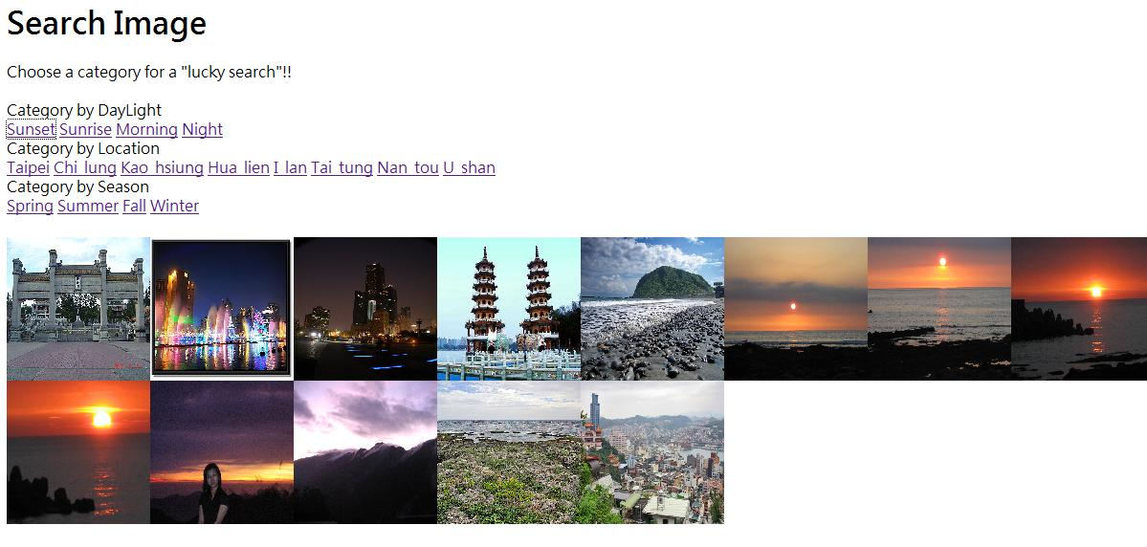
figure2: A subset of the “sunset” photo from the dataset, detected using contextual metadata.

EXIF- Exchangeable File Format
As we mention in the previous section, the importance of time-stamping and location information is well known now, there is a file format called EXIF for storing all the information about this picture, including flashing, shot time, white balance, ISO value, and also GPS information. But as far as we know, the information in exif can we modify by any users or application. So the accuracy and completeness of the exif file is still a big problem.
I did a survey for several photo sharing websites to check the completeness of information afford by the exif file, which is all modify by the website.
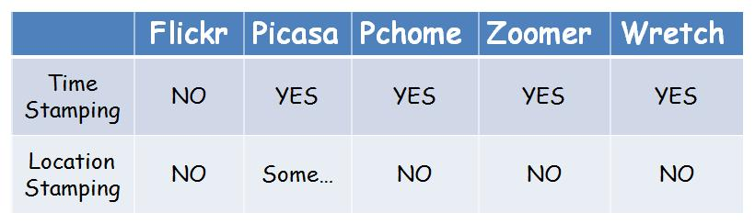

figure3: Compare the difference context data in the exif file from different photo sharing website.

It is not surprise that the geo-reference information is still not very popular on the web since the GPS equipment is not ready for all-pervading. But most website kept the time stamping in the photos.

Metadata Categories
The metadata categories my system generates and utilizes in the interface are list below.

Location
The location recorded for each photo refers to the location of the camera at the moment of capture. Another interesting location is the location of the subject of the photo, which we assume is approximately similar to the camera location.
The location is represented by latitude and longitude, which can be extracted from the GPS tag stored in the exif file, and must be translated to a useful location representation. A map is one option. In my implementation system, I group the photos into geographic clusters that are expected to make sense to the user. For example: a user that just travels around Taiwan will have a lot of photos in different cities and area. It will be very clear if we group the photos with location area. Like Taipei 101 in Taipei, sun-moon lake in Nan-tou …, etc.

Time of Day
Knowledge about the time of day a photo was shot can be used when searching for an image in a collection (e.g., one remembers a certain photo was taken late at night). In most cases, however, users set their camera clock once, usually when they operate the camera for the first time. The clock is used to timestamp all the photos taken with the camera. Indeed, this one-time setting is sufficient to sort all the pictures by time, or to associate pictures with the (approximate) month and date in which they were taken.
In the meantime, the scene image which I used in my system is restrict in the Taiwan area, so there is no time zone problem need to be solve in my system.

Season
The season information may not be very useful in most personal photo collection, but will still have some influence in the scene photos. As we know that the scene is very different in different season. For example: Snow in winter, flower in spring, sunny day in summer..., etc. But these evidence are not very obvious, only in some specific scene, but this problem can be improve if we combine this category with others, like locations.

System Architecture
The system architecture is showing as follow. First, we extract the information in exif file from every photo in our data set and store them into the database. Then we group the photo into many categories (Section3.) in case for easy to search. The user will use a photo browser(UI) to search the photos that he is looking for.
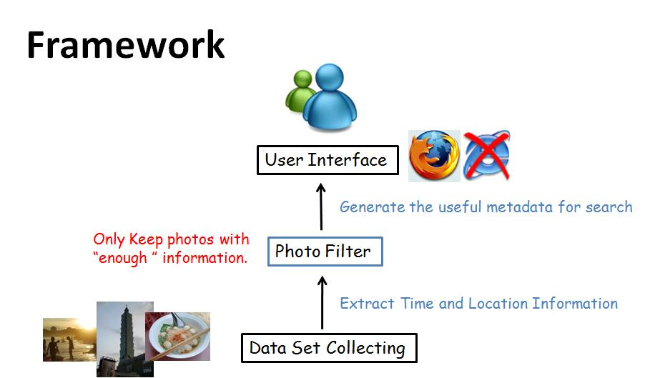
Figure4: the architecture of my system.

Experiment
The whole system was done by using PHP and MySQL and the testing platform is on Sony VAIO notebook. The precise experiment is as follow:
Since the purpose of my system is to verify Hector’s method in the web scope, I decided to focus my system on searching for scene photos in Taiwan area.
The first thing is the testing data set. It is practically impossible to find subjects with personal geo-referenced photo collections, as the geocoded photo technology is not widely available to consumers yet. Instead, I used a “location stamping tool”, a function support by Googles product – Picasa and Google Earth, to mark the photos with a location. I gather 20 photos with geo-tagging (and time -stamping) through Google earth, and geo-tag 80 photos which does not have location information. So the total testing data set is 100 Taiwan scene photos.
The exif information can be extract by using the PHP function called read_exif(), then we can get the time-stamping and geo-reference information. We stored the data into the database for the preprocessing. This increased the performance when the user search image group by categories.
Then we build up the user interface for the easy use for user to search image that they are looking for. In the user interface, user only has to click the category that he thinks the photos might be drop in, and the system will give a thumbnail for the query result.

Conclusion
Since Hector has done the user study survey in [1], it is very obvious that some metadata category would be very useful for user in searching.
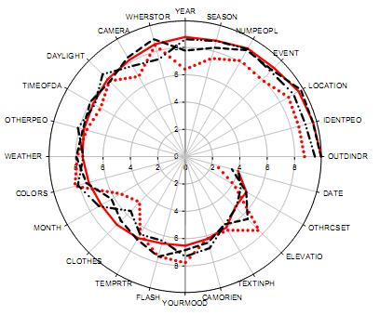
Figure5: Different categories that how well users remember their photos in Hectors survey.
My result show up that some category would be very useful when searching for scene in Taiwan, but some aren’t. For example: area location is very useful for a user searching for the scene in different area, comparing to the traditional method- text-based searching, Hectors method has a better accuracy. But like the category season, it seem that the searching performance is not well, since the phenomenon shown in the scene photo is not obvious at all. (Maybe this is because my testing data is not enough.).
So, in this project, I think that metadata is useful in some specific categories, but not all. Geo-reference information is very useful in for image searching. Maybe in the future day when GPS is wildly spread for every consumers, it’ll show its influence at then. So , no weather in personal photo collection scope or the web scope, metadata is both useful in these two area.
References
- Hector Garcia-Molina. Author, “Context Data in Geo-Reference Digital Photo Collection”, ACM Conference, April 2004.
- B. Shneiderman and H. Kang. Direct annotation: A drag-and-drop strategy for labeling photos. In
Proceedings of the International Conference on
Information Visualization, May 2000.
- W. Wagenaar. My memory: A study of autobiographical memory over six years. Cognitive psychology, 18:225–252, 1986.

