Parallel meta video search
Frans januar panto¹
¹Department of computer science and information engineering, National Taiwan University of Science and Technology, Taiwan
E-MAIL: m9715808@mail.ntust.edu.tw

Abstract:
Search engines are the most powerful resources for finding information on the rapidly expanding World Wide Web (WWW). The integration of such search tools is called metasearch engines. Metasearching of online videos is potentially useful Web application of distributed videos retrieval techniques. As we knows that in the web there are more than billion of video online and until this paper is created, no search engine can index all these videos. This paper constructed a real time information retrieval in parallel so the time to retrieve the data is faster. The data will be taken from 4 video providers and recomputed the documents score for all data that have been retrieved and give them ranking based on the score, so the relevancy of what user wants will be higher. This paper also compares the time to retrieve data serially with the time to retrieve data in parallel.
Keywords:
Metasearch; meta-video search; xml web service; distributed information retrieval; Web;

Introduction
A meta-search engine is a search tool that sends user requests to several other search engines and/or databases and aggregates the results into a single list or displays them according to their source. Metasearch engines enable users to enter search criteria once and access several search engines simultaneously. Metasearch engines operate on the premise that the Web is too large for any one search engine to index it all and that more comprehensive search results can be obtained by combining the results from several search engines. This also may save the user from having to use multiple search engines separately.
Meta-video search engines is metasearch engines that search for videos data. It does the same thing as metasearch engines but it is concentrate on searching videos data. Videos data in the internet are spreads all over the Web and the total amount of videos in the Web are more than billion and grow every day. Until this paper is created, no video search engines (e.g Youtube, Blinkx, Truveo, etc) have index all videos data in the Internet. Meta search engine videos help the user to collect all data from multiple search engines and then merge them into single list. Sometimes some video providers returned some video data that are not related to the query input by users, so by only merges the video without re-ranked the list won’t results very good to the user. Meta-video search also re-ranked the list that have been merged before and then return the results to the user with higher relevancy.
A straightforward way to perform result merging is to fetch the retrieved documents to the metasearch engine site and then compute their similarities with the query using generic document scoring function. The difficulty lies in the heterogeneities among the component search engines. For example, some component search engines may return a full description for each result while some don’t. As another example, different search engines will also return the “most viewed” videos while some returns “total viewed”. Because of these limitations, this paper considers to compute the data returned using title and description.
By taking the data one by one from each provider serially, it will be very time consuming, especially when there is so many data returned by the search engines. This paper also proposed a way to take the data in parallel. By taking the data in parallel, the execution time will be increase significantly, especially when the data is being processed are too much. But using to many parallel machines will not make it faster because of communication time from one to another.
Nowadays, some video search engines providers are provides the API to developers so they can fetch and process the data using feasible way. The data returned by them are in the form of well-formed XML, so the developers just need to parse the data from this XML instead of parse it from HTML semantically.
The rest of this paper is organized as follows. Section 2 describes where the datasets is taken. In section 3 introduce the techniques to compute document score using generic document scoring. In section 4 describes the system architecture. In section 5 provides the experimental results. Finally, section 6 concludes the paper.

Datasets
The datasets are the main component to build meta-video search engine. These datasets are taken from 4 established video search engines, youtube, truveo, blinkx, and revver. As mention in the previous part, some video search engine providers are provides API to the developer. The main purpose of this API is to provide the query results of videos data that they indexed, based on keyword that we send to them. In order to get data from this API, we must send the keyword to the each video provider. For youtube, truveo and blinkx, we just send the keyword in the url that they provides through parameter in the query string but for revver we need to send keyword through XML-RPC. Figure 1 is shows the example of some part the returned results from youtube with keyword “michael jordan”.

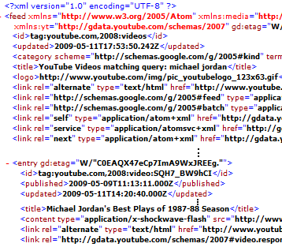
Figure1: Returned result in xml from YouTube with keyword “michael jordan”

In the example of result returned by YouTube, we can see that they provide link to the video, title of the video, category, thumbnail/images, etc. The data provides by YouTube are not the same with the data provides by other video search engines. These data will be used to build the meta-video search engines system. As mention before, the system will only use the title and description to compute the generic document score. With fast emerging of the xml, it’s not too hard to parse this data quickly and efficiently, thus the time to parse this data is very small (less than 100 milliseconds) and can be negligible.

Generic Document Scoring
Since document score were seldom reported by the video search engines providers and are not comparable, thus general scoring function had to be defined to returns comparable scores based on title and description in order to define an effective merging strategy. Thus for each video data i belonging to collection j for the query Q, will compute a weight, denoted w_{ij} as follows [1]:

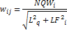 (1)
Within which NQW_{i} is the number of query words appearing in the processed field of the document I, L_{q} is the length (number of words) of the query, and LF_{i} is the length of the processed field of the document i.
This function returns a value of 0 when the intersection between request and the selected document field is empty. On the other hand, when all search terms and only those appear in the processed field, this function returns the maximum value of 1/√2 (or 0.7071) [1].
This suggested function is based on intuition that the more the search keywords appear in the processed document field(s) the greater the probability that the corresponding video is relevant [1]. Because we use two fields (title and description) and each of the field compute using equation (1), a weight value k between 0≤k≤1 is defined to weighting the title and description value. Because the more match keyword in the title is more preferable, then k value for title is 0.7 and the k value for description is 1-k, thus we have:

(2)

System Architecture
The system is beginning with the query input by users. After the input is sent, the query dispatcher will send the query to 4 nodes through XML Web services and then each node will send the query and fetch the data from each provider. After data is collected, the data is parsed and recomputed using generic document function as mention in the previous part. The results will be send back to the query dispatcher to be order by the highest score (more relevance to the query keyword) and the results is formatted and show to the users. Here, managing for load balancing of the parallel machines is not considered and use best efforts instead. The parallel machines assumed that always in idle condition and ready to take the job at any given time. The system architecture is shows in figure 2.
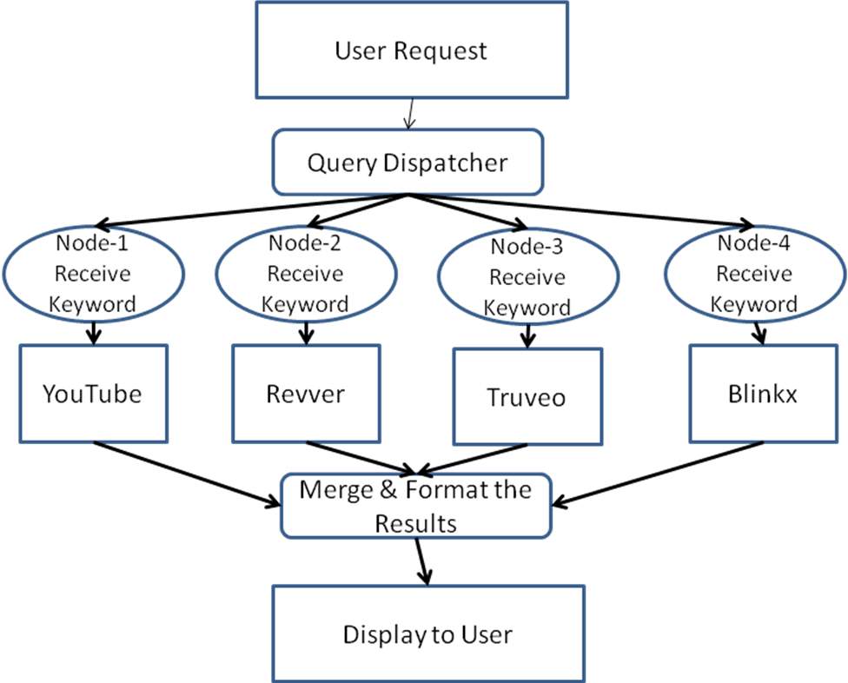
Figure2: Meta-video search engine’s architecture

Experiments
The experiment is conducted by querying the meta-video search engine with different total results and each is perform 20 times. The total results returned are 5, 10, 20, 30, 40, 50, and 100 results. All experiments are performing on standard PCs. Because the Internet speed is the main concern of this experiment so the experiment is conducted when the Internet speed is in the highest speed.
First, the experiment for serial execution is performed. The results are shows in table1 (actually the number of results processed by system is multiply by 4, because the system uses 4 providers).

#Results | #query | Mean Time | Std Deviation
5 | 20 | 0.5938 | 0.2067
10 | 20 | 0.7652 | 0.2187
20 | 20 | 0.7088 | 0.3088
30 | 20 | 1.1103 | 0.2688
40 | 20 | 1.6591 | 1.2438
50 | 20 | 1.9349 | 0.5566
100 | 20 | 4.5562 | 0.9662
Table1: Results of serial execution

We can see that serial execution performs well on query that returned results less than 100. So it can be concludes that if the query results more than 100 the time will grow fast and it’s not acceptable to use serial execution in meta-video search since user have to wait so many seconds to get his/her results. These results are based on simple intuition that the more results returned, the more data to be processed, thus the time will be longer.
Second, the experiment for parallel execution in 4 nodes is performed. The results of parallel execution are shows on table 2 and figure 4.

#Results | #query | Mean Time | Std Deviation
5 | 20 | 0.3618 | 0.0804
10 | 20 | 0.4536 | 0.1056
20 | 20 | 0.8594 | 0.3938
30 | 20 | 1.0615 | 0.3978
40 | 20 | 1.3661 | 0.4339
50 | 20 | 1.7796 | 0.6728
100 | 20 | 1.9807 | 0.6130
Table2: Results of parallel execution using 4 nodes

We can see that using parallel execution, the time for any results are outperforms the serial’s time, especially when the results are more than 100 results, the parallel execution results 2 times faster than serial execution. The explanation for these results is very obvious, it’s because the execution are done in parallel instead of serial. Then parallel execution using 2 nodes is conducted and the resulting time is slightly better. This is because of communication time, especially for small number of data. The time to execute in parallel using 2 nodes is shows in table 3.

#Results | #query | Mean Time | Std Deviation
5 | 20 | 0.3214 | 0.0145
10 | 20 | 0.4121 | 0.1016
20 | 20 | 0.8012 | 0.3457
30 | 20 | 0.9213 | 0.2389
40 | 20 | 1.2289 | 0.3481
50 | 20 | 1.6921 | 0.2145
100 | 20 | 2.0807 | 0.5623
Table3: Results of parallel execution using 2 nodes

Sometimes data returned by video search engines provider are not related. Here generic document score is useful. By using generic document scoring, the more keywords appear in the processed fields (title and description), the score will be higher, and thus the score for irrelevant data will be 0. Some examples for the retuned results and the score are shown in table4.
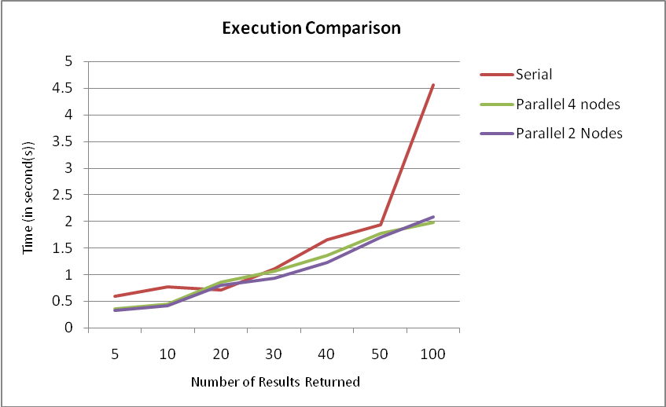
Figure3: Comparison of execution time

Title | Description | Score
Michael Jordan Top 40 Moments | Michael Jordan | 0.252838559143541
The New Michael Jordan | A lot of people have been talking about who is the next Michael Jordan, some say Lebron but I say this guy takes the cake. MJ could never dunk this well. | 0.14704053424958
The Air Up There: Michael Jordan | Michael Jordan Clintches Dunk Title w/ Free Throw Line Dunk | 0.134091556832688
Talkin' Hoops with Spike Lee | Spike Lee discusses the New York Knicks, Kobe Bryant, his dream team starting 5 and LeBron James | 0
Great NBA Playoff Shots | SportsCenter takes a look at some of the greatest shots in NBA Playoff history | 0
Table4: Example of results returned followed by document score with keyword “michael jordan”

As we can see, the last two results are not relevant with the keyword, thus the scores are 0 and won’t be displayed to the users.

Conclusions
Parallel Meta-video search engine is presented. It’s very practical to build the meta-search engines or meta-video search engines based on parallel execution. The reason behind to using this parallel is because the data are fetch in real time from the video search engines providers, thus we don’t need to manage the database and in other hand we can get a reasonable time to show the results to the users, yet up to date. It is must be consider not to use over parallel machines than it needs, because the communication time between the query dispatcher and the nodes must also be consider.
The generic document function that uses for this system shows better results than the original one. This is because data from 4 video providers is merged and re-ranked into single list, thus the relevancy of the keyword and the results is higher.
As far as future work is concerned, an obvious next step would be manage the load balancing of the parallel machines so it become always reliable when there is job to be execute. Using the scheduling and optimization will be helping the system to make the work load in parallel machines are balance.

Acknowledgements

This project is part of Advance Database System course in National Taiwan University of Science and Technology teach by Professor Yi-Leh WU.
References
- Y. Rasolofo, D. Hawking, J. Savoy. Result Merging Strategies for a Current News Metasearcher. Inf. Process. Manage, 39(4), 2003, pp.581-609.
- YouTube API and Tools. [Online] Available at: http://code.google.com/apis/youtube/overview.html
- Revver Developer Center. [Online] Available at: http://developer.revver.com/
- Truveo Video Search Developer. [Online] Available at: http://developer.truveo.com/
- Blinkx Developer Network. [Online] Available at: http://www.blinkx.com/devnet/

