Implementation of Battery Pack Tracking System
yu-chih wang
Department of Computer Science and Information Engineering,
National Taiwan University of Science and Technology, Taipei, Taiwan
E-MAIL: M9715914@mail.ntust.edu.tw

Abstract:
Recently there are many news about notebook battery modules burned in some major notebook manufacturers, such as SONY, DELL, Apple...etc. When the battery burned issue happened, these manufacturers usually call back their problem production from over the world.
It is very a difficult job to estimate accurately the amount that the battery packs should be called back without a reliable management system. Another difficult job is to track manufacturing information of battery packs. For these purpose, we develop a systematic procedure to help tracking every battery pack when in manufacturing process. In this proposed project, we mainly use DB Designer 4.0 to implement ER modeling also Microsoft SQL Server as backend database. When developing web application, we use Microsoft ASP.NET as main tool.
Keywords:
Shop Floor Control System; MES; Barcode Tracking System; Database; ER Model

Introduction
In general, Shop Floor Control System can well control manufacturing process of battery packs, however, these systems could not keep more detailed information about how the product been tested in the production line. We can consider such condition: if something wrong happen to our production, how do we know the real status when it was tested in the factory and how do we find its original data by barcode only. The original data sometimes is helpful to analysis the root cause of problems. In the whole manufacturing process, we control every battery pack by barcode management because the barcode is a unique key in our system.
This paper will introduce some basic concept of manufacturing process of battery packs. We design some sub systems according to the manufacturing process. This tracking system is based on these sub systems, in the manufacturing process, the system will keep tracking the status in every stage.

Motivation
Most of business applications, like ERP, MES, Shop Floor Control System [1], could provide many administrative workflow to an enterprise. But these applications can not provide the tracking function of their product when shipped to the clients. To achieve the goal of tracking function, we design some sub-systems according our real manufacturing process. We briefly describe the main functions of these sub-systems for those who have no any background of pack manufacturing.

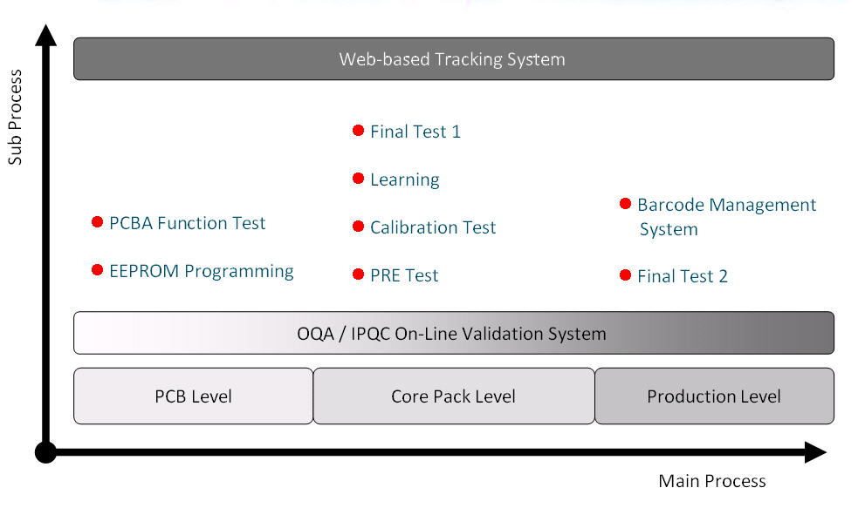
Figure 1. System Roadmap

Background
In this implementation we divide main process into four level, they are PCB Level, core pack level, production level and service level. To verify the quality of manufacturing process, OQA validation is necessary in the whole process , as in Figure 1.

There are some sub systems corresponding to these main processes.
- EEPROM Programming is the first process of our manufacturing process which programming data into EEPROM that will make battery pack work normally. If the EEPROM is not programmed correctly, the pack may not work properly.
- PCBA Function Test is performed after EEPROM programmed which make sure the pack can charge and discharge normally. The most important function we have to test is protection test. When over charge or over discharge happens, the protection function of PCB is triggered. The gauge IC will stop charging or discharging function, that will make the battery pack safe.
- PRE TEST System is performed after the PCB is assembled with cells (we call this as core pack).The goal of PRE TEST is to wakeup the gauge IC both simply check the charge and discharge function works.
- Calibration System mainly improves the accuracy of gauge IC measurement including voltage, current and temperature. The calibration system will compute the gain and offset by gauge IC calibration procedure provided by IC manufacturer, such as TI, Neotec ...and so on. we can perform EEPROM check procedure to check the content of EEPROM.
- Learning is another important process of manufacturing which performs a full cycle of charge and discharge. If the learning process is finished, the cycle count of the pack will start from 1 and the Max Error will change from 100% to 2%.
- Final Test is usually conducted after learning process. Just as its process name, it's the final process of the whole manufacturing process. In this stage, we just check the pack if work properly.
- Barcode Management System is a production level test which keeps tracking the barcode information of the pack. In our implement, the barcode plays an important role of data tracking. We have to make sure it is unique in the whole system.
- Web Tracking System is the core function of service level and it is the main goal of our implementation. This web-based application can monitor the status of the pack in processing also provide a service interface to the customers. Customers can query the progress of the order and query the test detailed information from the application.
- Automated Email-Alarm System is a multi-functions email application. It can summarize the results and send mail to related members. The most important feature is that this sub-system can detect abnormal data in the database then send mail to administrators to handle that. It is a flexible application which the function could be extended easily according to our real requirements.

System Implementation
Our implementation includes several major parts; they are how the system communication with battery pack, system architecture designing job, and ER model diagram about the system we proposed. In addition to these jobs, this section will introduce the structure of automated information feedback system,

Communication
When the test procedure is conducted, we need an interface for system to communication with battery pack. In this system, we use Texas Instruments EV2200 as a interface board which supports SMBus, I2C, and HDQ protocol.

System Architecture
This battery pack tracking system is composed of many manufacturing subsystems which are client-server architecture and a web application with 3-tier.The main function of the subsystems is to perform pack testing and keep tracking all data that the system generated. Web application could allow users to access data anywhere, anytime. For the well-controlled process, we permit only battery pack with PASS result could enter next process. So we build a database server to store detailed information of every pack that helps to make sure we can implement this feature. In this implementation, we use Microsoft IIS Server as a web server. Microsoft Internet Explore 6.0 is our recommended client-side browser.

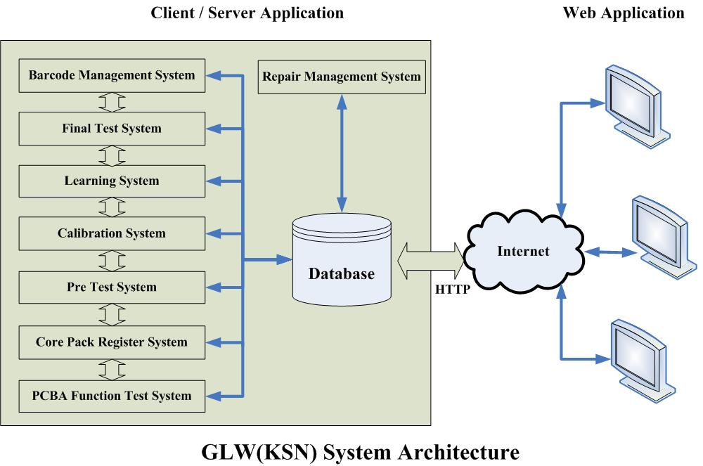

Figure 2. System Architecture

ER Model Diagram
When implementing this system, we use DB Designer 4.0[3] to design database schema which is a open source software which is executable on different platform for example Windows, Linux, Unix…etc. One of the most important feature of this system is traceability. That means all the test data, including retry process, will be record in the database. For this reason, the main table ManufData will has a ‘one to many’ relationship. That means one pack may has many records even in a one process, as in Figure 3

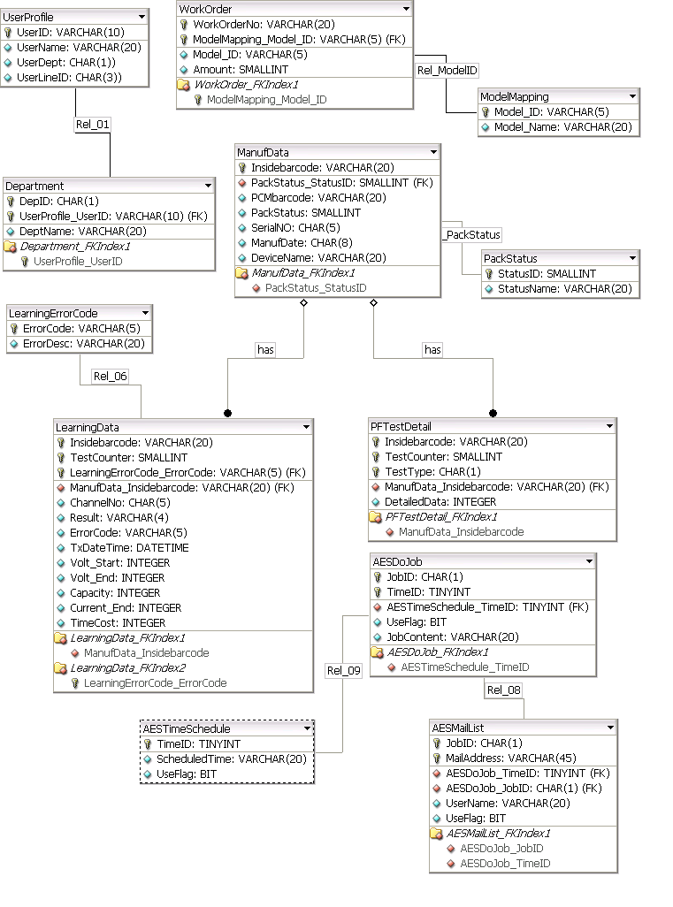

Figure 3. ER Model Diagram

Automated Email-Alarm System (AES)
AES is a schedule-based XML application which is responsible of abnormal data detection. In this application, we can pre-define the rules and time schedule for which the application can query from database according to these rules, and then send these critical information to mail list predefined in the system. To implement AES, we use Jmail [2] component which is easily for usage to develop this email-based application.

The process of AES we proposed here, as in Figure 4 are:
- Start process (JobID) according to scheduled time
which we pre-define in table AESRealTime
- Query data from pre-defined rule which is join to
JobID of AESRealTime
- Generate and execute SQL command according to rule.
- Return XML-based data
- Transform XML format data to HTML by XSLT
- Get mail list by AESMailList join to AESDoJob
- Send mail by using Jmail component

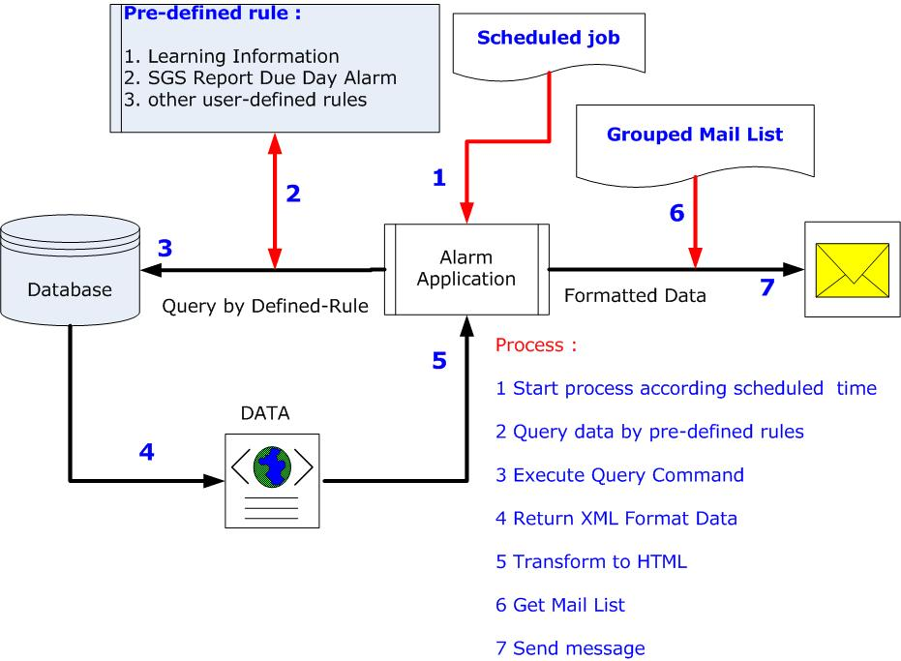

Figure 4. AES Process Chart

Tools in this project
In order to develop this system, we use the following tools:

Data Modeling: DB Designer 4.0
Sub System development: Visual Basic 6
Database: MS SQL Server 2000
Web Development Environment: ASP.NET (C#)
XML Application: Microsoft XML 6.0 Parser SDK.

Result
The main goal of this project is to build a web-based tracking system which can access from anywhere, anytime. We design many administrative functions for management purpose in this web system not only for tracking function.
We are still continued to improve the function of this tracking system and it runs well by now. Figure 5 is a screenshot of our implementation

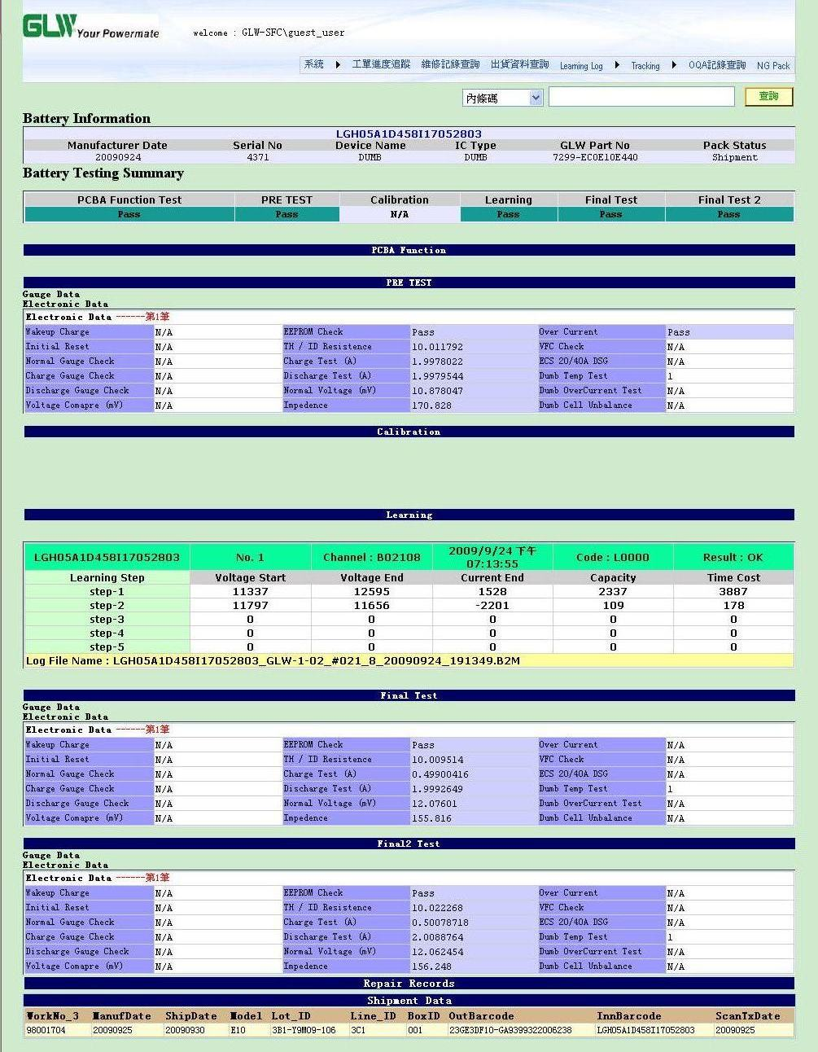

Figure 5 Result

Conclusions

We implement an application of web-based battery pack tracking system with database management system. Also we create an ER model diagram for database modeling which is implemented in Microsoft SQL Server. However, the web-based tracking system is based on many sub-systems designed for manufacturing process.
Our future works are trying to discovery some useful information from data mining viewpoint

Acknowledgements
In order to finish web-based tracking system project, My Company, GLW, provide me many supports and resources. Furthermore, I really appreciate my Advanced Database Management course instructor, Professor Yi-Leh Wu, who gives me many suggestions in the course about my final project.
References
- JA Harding, M Shahbaz, A Kusiak, “Data Mining in Manufacturing : A Review”, Journal of Manufacturing
Science and Engineering, 2006.
- Jmail component web site http://www.dimac.net/
- DB Designer http://www.fabforce.net/dbdesigner4/

