Could Pyramid-Technique Break the Curse of Dimensionality?
WEN-HUNG WANG¹
¹Department of computer science and information engineering, National Taiwan University of Science and Technology, Taiwan
E-MAIL: d9615006@mail.ntust.edu.tw

Abstract:
In this project, I try to confirm that if Pyramid-Technique could truly break the curse of dimensionality. Pyramid-Technique is an index method for high-dimensional data space. It is highly adapted to range query processing. In contrast to all other index structures, the performance of Pyramid-Technique does not deteriorate when processing range queries on data of higher dimensionality. The Pyramid-Technique is based on a special partitioning strategy which is optimized for high-dimensional data. The basic idea is to divide the data space first into 2d pyramids sharing the center point of the space as a top. In a second step, the single pyramids are cut into slices parallel to the basis of the pyramid. These slices form the data pages. To demonstrate the practical relevance of the technique, I experimentally compared the Pyramid-Technique with the K-d tree, and the Linear Scan. The results of our experiments using both, synthetic and real data, demonstrate that Pyramid-Technique outperform than other index structure algorithms in some case.
Keywords:
Pyramid-Technique; K-d tree; high-dimensional index structure;

Introduction
During recent years, a variety of new database applications has been developed which substantially differ from conventional database applications in many respects. For example, a content-based search is essential which is often implemented using some kind of feature vectors [1] [5]. All the new applications have in common that the underlying database system has to support query processing on large amounts of high-dimensional data.
What is the curse of dimensionality? The curse of dimensionality is to describe the problem caused by the exponential increase in volume associated with adding extra dimensions to a (mathematical) space. For example, 100 evenly-spaced sample points suffice to sample a unit interval with no more than 0.01 distance between points; an equivalent sampling of a 10-dimensional unit hypercube with a lattice with a spacing of 0.01 between adjacent points would require 10²⁰ sample points: thus, in some sense, the 10-dimensional hypercube can be said to be a factor of 10¹⁸ "larger" than the unit interval. Another way to envisage the "vastness" of high-dimensional Euclidean space is to compare the size of the unit sphere with the unit cube as the dimension of the space increases: as the dimension increases, the unit sphere becomes an insignificant volume relative to that of the unit cube; thus, in some sense, nearly all of the high-dimensional space is "far away" from the centre, or, to put it another way, the high-dimensional unit space can be said to consist almost entirely of the "corners" of the hypercube, with almost no "middle". The curse of dimensionality is a significant obstacle to solving dynamic optimization problems by numerical backwards induction when the dimension of the 'state variable' is large. It also complicates machine learning problems that involve learning a 'state-of-nature' (maybe infinite distribution) from a finite (low) number of data samples in a high-dimensional feature space.
Although Stefan Berchtold [4] etc. figure out that Pyramid-Technique does not deteriorate on data of high dimensionality, but there are still some questions: when data is high dimensionality, they always concentrate on the hyper-sphere. Even if Pyramid-Technique can transform data to one-dimension space, almost pages of index structure should be null. If it is true, the performance of Pyramid-Technique would be as sequential scan. The goal of this project is to confirm that if Pyramid-Technique could truly break the curse of dimensionality.
The rest of this project is organized as follows: In section 2, I give an overview of the related work in high-dimensional indexing. In section 3, I introduce the algorithms of Pyramid-Technique. To confirm the performance of Pyramid-Technique, I show the experiments and results in section 4. Finally, I find out that Pyramid-Technique outperforms than other index structure in some case, the weakness and limitations, in section 5.

Related work
Recently, a few high-dimensional index structures have been proposed.
In [2], Jain and White introduced the VAM-Split R-tree and the VAM-Split KD-tree. Both are static index structures i.e. all data items must be available at the time of creating the index. VAM-Split trees are rather similar to KD-trees [3], however in contrast to KD-trees, splits are not performed using the 50%-quantile of the data according to the split dimension, but on the value where the maximum variance can be achieved. VAM Split trees are built in main memory and then stored on secondary storage. Therefore, the size of a VAM Split tree is limited by the main memory available during the creation of the index.

The Pyramid-Technique
The basic idea of the Pyramid-Technique is to transform the d-dimensional data points into 1-dimensional values and then store and access the values using an efficient index structure. In order to define the transformation, I first explain the data space partitioning of the Pyramid-Technique.
The Pyramid-Technique partitions the data space in two steps: in the first step, we split the data space into 2d pyramids having the center point of the data space (0.5, 0.5, ..., 0.5) as their top and a (d-1)-dimensional surface of the data space as their base. In a second step, each of the 2d pyramids is divided into several partitions. In the 2-dimensional example depicted in Figure 1, the space has been divided into 4 triangles (the 2-dimensional analogue of the d-dimensional pyramids) which all have the center point of the data space as top and one edge of the data space as base (Figure 1 left). In a second step, these 4 partitions are split again into several data pages parallel to the base line (Figure 1 right). Given a d-dimensional space instead of the 2-dimensional space, the base of the pyramid is not a 1-dimensional line such as in the example, but a (d-1)-dimensional hyperplane. As a cube of dimension d has 2d (d-1)-dimensional hyperplanes as a surface, we obviously obtain 2d pyramids.
Numbering the pyramids as in the 2-dimensional example in Figure 2a, we can make the following observations which are the basis of the partitioning strategy of the Pyramid-Technique: All points located on the i-th (d-1)-dimensional surface of the cube (the base of the pyramid) have the common property that either their i-th
Figure 1. Partitioning the Data Space into Pyramids

coordinate is 0 or their (i-d)-th coordinate is 1.We observe that the base of the pyramid is a (d - 1)-dimensional hyperplane, because one coordinate is fixed and (d - 1) coordinates are variable. On the other hand, all points v located in the i-th pyramid p_{i} have the common property that the distance in the ith coordinate from the center point is either smaller than the distance of all other coordinates if i<d, or larger if i≧d.
Figure 2. Properties of Pyramids

Figure 2b depicts this property in two dimensions: all points located in the lower pyramid are obviously closer to the center point in their d₀-direction than in their d₁-direction. This common property provides a very simple way to determine the pyramid p_{i} which includes a given point v: we only have to determine the dimension i having the maximum deviation from the center.
Definition 1: (Pyramid of a point v)
A d-dimensional point v is defined to be located in pyramid p_{i},
Another important property is the location of a point v within its pyramid. This location can be determined by a single value which is the distance from the point to the center point according to dimension j_{max}. As this geometrically corresponds to the height of the point within the pyramid, we call this location height of v (c.f. Figure 3)
Definition 2: (Height of a point v)
Given a d-dimensional point v. Let p_{i} be the pyramid in which v is located according to Definition 1. Then, the height h_{v} of the point v is defined as
Figure 3. Height of a Point within it’s Pyramid

Using Definition 1 and Definition 2, we are able to transform a d-dimensional point v into a value (i+h_{v}) where i is the index of the according pyramid p_{i} and h_{v} is the height of v within p_{i}. More formally:
Definition 3: (Pyramid value of a point v)
Given a d-dimensional point v. Let p_{i} be the pyramid in which v is located according to Definition 1 and h_{v} be the height of v according to Definition 2. Then, the pyramid value pv_{v} of v is defined as
pv_{v} = ( i + h_{v} )
Note that i is an integer and h_{v} is a real number in the range [0, 0.5]. Therefore, each pyramid p_{i} covers an interval of [i, (i+0.5)] pyramid values and the sets of pyramid values covered by any two pyramids p_{i} and p_{j} are disjunct. Note further that this transformation is not injective i.e., two points v and v’ may have the same pyramid value. But, as mentioned above, we do not require an inverse transformation and therefore we do not require a bijective transformation.

4. Experiments
To demonstrate the practical impact of the Pyramid-Technique and to verify our theoretical results, we performed an extensive experimental evaluation of the Pyramid-Technique and compared it to the following competitive techniques:
- K-d tree
- Sequential Scan
My evaluation comprises both, real and synthetic data sets. My synthetic data set contains 140,000 uniformly distributed
points in 128, 65, 36-dimensional data space. In my first experiment, I compare time cost of three algorithms in querying 1,000 random points. In table 1, we can see that even if dimension changes, performance of three algorithms are similar. It is because that data distributed uniformly, pages in index structure won’t grow up exponentially.

Talbe 1. Comparison of time cost (second) in synthetic data
 | Pyramid-Technique | K-d tree | Sequential Scan
128d | 0.032 | 0.032 | 963
65d | 0.03 | 0.031 | 942
36d | 0.046 | 0.032 | 971

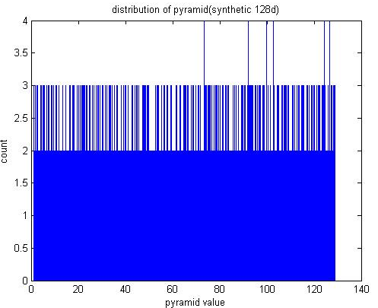
Figure 4. Histogram of pyramid value (128-dimension)

In figure 4, x axis is pyramid value and y axis is numbers of points. We can see that distribution of pyramid value is almost uniform.
In a second experiment, I use real data extracted from images by SIFT and PCA-SIFT respectively. Numbers of data are about 140,000 points in 128-dimension and 135,000 points in 36-dimension. Table 2 shows that performance of Pyramid-Technique and K-d tree is better in PCA-SIFT data. Figure 5 shows that degree of concentration in SIFT data is much more than in PCA-SIFT, which makes data concentrate in some pages.

Talbe 2. Comparison of time cost (second) in real data
 | Pyramid-Technique | K-d tree | Sequential Scan
SIFT data | 1.241 | 52.24 | 959
PCA-SIFT data | 0.11 | 0.078 | 957

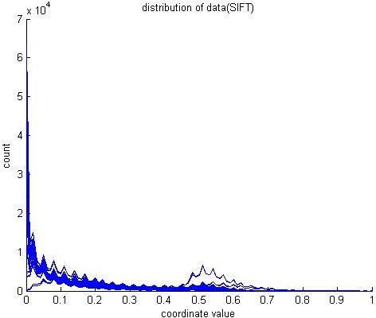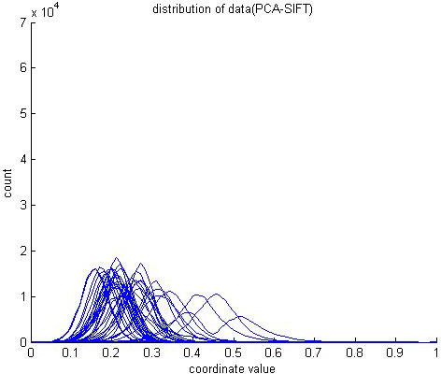
Figure 5. Coordinate distribution (left: SIFT, right: PCA-SIFT), x-axis is coordinate value and y-axis is numbers of data.

In order to confirm factors which affect performance, I take a third experiment as table 3. There are 65, 36-dimension data extract from 128-dimension SIFT data. When dimension arise, performance of Pyramid-Technique won’t change, but performance of K-d tree becomes worse.
Table 3. Comparison of time cost (second) in SIFT data
 | Pyramid-Technique | K-d tree | Sequential Scan
SIFT 128d | 1.241 | 52.24 | 959
SIFT 65d | 1.996 | 31.797 | 953
SIFT 36d | 1.529 | 16.219 | 955

To reconfirm it, I build data with extreme concentration as figure 6. Time cost of Pyramid-Technique and K-d tree are 109 seconds and 155 seconds respectively.
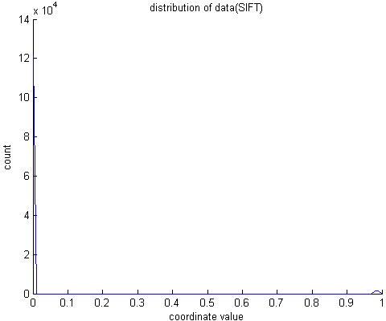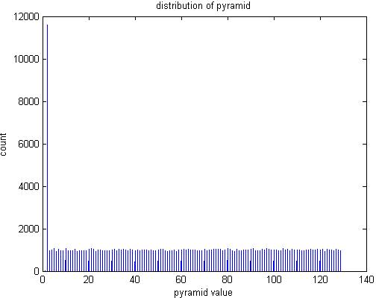
Figure 6. Extreme sample. Row 1 figure is coordinate distribution, and row 2 is pyramid distribution.

5. Conclusion
In this project, I confirmed that Pyramid-Technique outperform than K-d tree when data is highly concentrated. It won’t be deeply affected by dimensionality but distribution. This is because that even if data is highly concentrated, Pyramid-Technique can transform data to a one-dimension space and reduce the degree of density. No matter dimensionality or distribution, Sequential Scan won’t be affected. Performance of K-d tree deteriorate when data is highly concentrated, especially data is high dimensionality.
References
- D. Lowe, “Distinctive Image Features from Scale-Invariant Keypoints”, International Journal of Computer Vision, Vol.60, pp.91-110. Nov. 2004
- Jain R, White D.A., ‘Similarity Indexing: Algorithms and Performance’, SPIE Storage and Retrieval for Image and Video Databases IV, Vol. 2670, pp. 62-75, 1996.
- Robinson J. T., “The K-D-B-tree: A Search Structure for Large Multidimensional Dynamic Indexes”, ACM SIGMOD, pp. 10-18, 1981.
- Stefan Berchtold, Christian Bohm, Hans-Peter Kriegel, “The Pyramid-Technique: Towards Breaking the Curse of Dimensionality”, ACM SIGMOD, June 1998.
- Y. Ke and R. Sukthankar, “PCA-SIFT: A more distinctive representation for local image descriptors”, IEEE CVPR, 2004.

