analyzing the necessary of join operation in sensor network
Tsung-TE LAI(“賴宗德”)
Department of computer science and information engineering,
National Taiwan University of Science and Technology, Taipei, Taiwan
E-MAIL: a9415001@mail.ntust.edu.tw

Abstract:
Current wireless sensor network database systems, such as TinyDB [1] or Cougar [2], can provide SQL-like query function. For example, they can do GROUP-BY or Aggregate function. However, they don’t support join query operation. In this report, I tried to analyze the necessary of join operation by a given dataset off-line. The experimental evaluation results show that it is useful to implement join query operation in wireless sensor network environment.
Keywords:
Wireless Sensor Network, Join Queries

Introduction
Wireless sensor network is an emerging technology that has considered as a very useful tool for variant domains, such as habitat detection and volcano monitoring[3]. However, wireless sensor nodes are well-known for their resource-constrained. For instance, they have very limited power, processing speed, storage capacity, and communication bandwidth. These resource limitations lead to new research challenges.
As about the data management in wireless sensor network, there exist two main database systems. One is TinyDB, another is Cougar. Both of these systems provide SQL-like function. Users can collect data from sensor network by issuing SQL-like query language. These systems also developed aggregate queries such as, COUNT, SUM, and AVG. These in-network aggregation techniques can significantly reduce the amount of data transmission, since reduce the power of sensor nodes.
However, in certain scenarios, simple select or aggregation queries are not good enough handle all the user’s query requirements. One scenario is that we might interest in tracking the correlations among sensor data with in a time window to do event detection. For example, in volcano monitoring, scientists are interested in the pressures detected within a certain region around the volcanic mountain. After noticing that the volcanic activity of the mountain has increased, they may want to know whether the pressures detected have passed a certain threshold and is continuously increasing within some period of time. This query can be written into this form,

SELECT P1.pressure, P1.time, P2.pressure, P2.time
FROM Pressure AS P1, Pressure AS P2
WHERE P1.pressure > threshold
AND P2.pressure > P1.pressure
AND P2.time > P1.time
AND P2.time − P1.time < h

In this query, threshold value is a constant value that is given by user, and Pressure table represent the table in sensor node, which collects pressure information. From this query, we can observe that there is a join operation there.
In the existing database system in sensor network do not provide join function. If one wants to accomplish this query, he has to ask all the sensor nodes send back their data back to base station, and then let bask station to perform join operations. However, this would result in high data transmission and reduce the power resource for each node. Thus, it is important to implement join operation in order to reduce high data transmission for this kind of scenarios.
The following sections are summarized as follow. Section 2 describes the approach to implement join operation in sensor network. Section 3 describes my experiment environment and experimental result. Finally, I conclude this report in section 4.

The approach to implement join operation in sensor network --- TPSJ [4]
In this section, I will briefly describe the approach to implement join operation in sensor network. This approach is called two-phase window self-join (TPSJ) [4]. Section 2.1define the execution scenario. Section 2.2 outlines the TPSJ approach.

2.1 Execution scenario
The execution scenario that we are interested in is to find the correlations among sensor data within a time window. The correlation here means the relation among data on one single mote. The general query form of this requirement can be defined as the following form:
SELECT S1.AT1, S2.AT2
FROM Sensor AS S1, Sensor AS S2
WHERE p1(S1.AT3)
AND p2(S1.attj , S2.atth)
AND window (S1.ts, S2.ts,W)

where Sensor is a table on sensor nodes, p1 is a predicate for data filtering, p2 is a predicate for join operation, and window(S1.ts, S2.ts,W) is a conceptual predicate to restrict the sample to be in a period.

2.2. Two-phase self-join (TPSJ) approach
This section discusses the TPSJ approach. Basically, as the title suggested, TPSJ can be divided into two phases, which are query decomposition and self-join processing. The basic idea of doing this is to do make the original query to be more efficient. The original query would be decomposed into following two forms:
Form1
SELECT S.AT1 INTO R1
FROM Sensor AS S
WHERE p1(S.AT3)

Form 2
SELECT S.AT2
FROM R1, Sensor AS S
WHERE p2(R1.attj , S.atth)
AND window(R1.ts, S.ts,W)

From 1 would be the first phase in TPSJ, and From2 would be the second phase in TPSJ.
The first phase has two purposes. One purpose is to select some tuples that are likely to contribute the final result. These tuples will be used to do data filtering in phase two. Another purpose is to determine when to start a window join operation. If form 1 returns more than one tuple back to base station, then we will issue the second query.
The purpose of second phase is to use the candidate tuple in phase one to perform join operation to do event detection within a time window.
Let us use the query form of volcano monitoring in section 1 to give an example. The phase one query decomposition would be as follow:
SELECT P.pressure, P.time INTO R1
FROM Pressure AS P
WHERE P.pressure > threshold

Let us also use figure 1 as an example for illustration the above query.
In figure 1, each sensor node maintains a table that consists of sensor reading and epoch. Node 0 is our base station for collecting data. The threshold value in figure one is 500. Figure 1(a) shows each the sensor readings at epoch one, and Figure 1(b) is the result of phase one. Node 3 and 2 satisfy with the predicate, so they send their reading value back to base station.
The phase two query decomposition would be as follow:
SELECT P.pressure, P.time
FROM R1, Pressure AS P
WHERE P.pressure > R1.pressure
AND window(R1.time, P.time, h)

Let us also use figure 2 as an example for illustration the above query.

In figure 2, the window size (h) is 10. In figure 2(a), the base station injects the results from first phase into network. Each sensor node now has this table, which has 510 and 530 readings. After ten epochs, node 1, 3, and 5 have the readings which are greater than 510 and 530. Therefore, the final result is given by the data reading from node 1,3,5.

Experiment
In my experiments, I use the dataset from Intel lab at Berkeley[5] and MySQL to analyze the TPSJ algorithm.
The schema of the dataset is as follow.

Date | time | epoch | id | temp | humidity | light | volt

In my experiments, I only use the attributes in red color to do analysis.
The network topology is shown in figure 3.

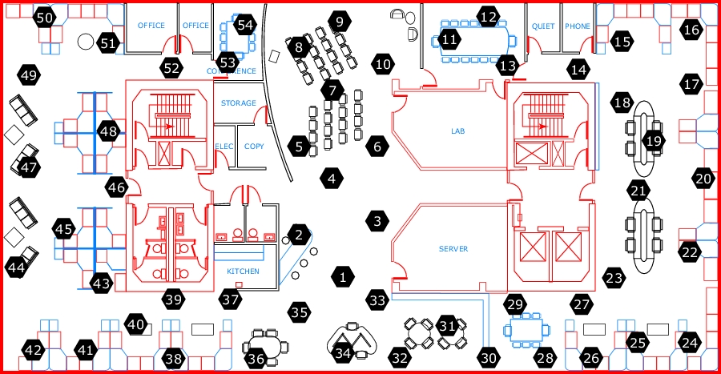

Figure 3 Network topology

Figure 3 is the map of the Intel research lab at Berkeley. There are 54 sensor nodes in this lab. For this experiment, I use node 47, 53, 12, 13, 37, and 30 to form a tree topology. Node 47 is the base station.
The query to evaluate the TPSJ in this experiment is as follow:
SELECT A.id, B.id, A.humidity, B.humidity
FROM sensor as A, sensor as B
WHERE A.humidity > threshold
AND A.humidity > B.humidity
AND window ( B.epoch, A.epoch, h)

Besides TPSJ, I also try to analyze the traditional method to accomplish join operation. That is, all the sensors send their sensor readings back to the base station and let base station to do join operation. By this comparsion, I can analyze the necessary of join operations in sensor network.
The evaluation metric for this experiment is the number of data transmission in the whole network. Figure 4 shows the experimental result.

Use 1.5 centimeters (0.6 inches) for the left and right margins. Use Times New Roman and font size 10 for text (character size). Do not use bold in the main text; if you want to emphasize specific parts of the main text, use italics. Start a new paragraph by indenting it from the left margin

Figure 4 Number of data transmissions in network

The basic line indicates the traditional method to accomplish join operation. Join (N) means that we set the threshold value to be N in TPSJ. In this case, the threshold is equal to 46, 47 and 48 respectively. For the window size, the range is from 100 to 1000.
From figure 4, we can see that the TPSJ is much outer perform than the basic method, especially when the selectivity is low, i.e. higher threshold value.

Conclusions
In this project report, I found that join operation is not supported by current sensor network database system. However, for some certain scenario like event detection, it is necessary to have join operation in the sensor network. My experimental result shows that join operation can dramatically reduce the number of transmission in the network. To reduce the number of transmission means to reduce the power of each sensor motes. Therefore, we can conclude that join operation is necessary for sensor network.
References
- S. Madden, M. Franklin, J. Hellerstein, and W. Hong. Tinydb: An acquisitional query processing system for sensor networks. In TODS, 2005.
- Yong Yao and J. E. Gehrke. Query Processing in Sensor Networks. In Proceedings of the First Biennial Conference on Innovative Data Systems Research (CIDR 2003), Asilomar, California, January 2003.
- Fidelity and Yield in a Volcano Monitoring Sensor Network, Geoff Werner-Allen, Konrad Lorincz, Jeff Johnson, Jonathan Lees, and Matt Welsh. In Proceedings of the 7th USENIX Symposium on Operating Systems Design and Implementation (OSDI 2006), Seattle, November 2006.
- X. Yang, H. B. Lim, M. T. Ozsu, and K. L. Tan, "In-network execution of monitoring queries in sensor networks," Proc. of the 2007 ACM SIGMOD International Conference on Management of Data (SIGMOD 2007), pp. 521-532, Jun 2007.
- http://db.csail.mit.edu/labdata/labdata.html

